The American Revolution
Packet #2
- Britain and Its American Colonies
  - _____________________________________ British colonists formed a large and thriving _________________________________________________________________________
  - ____________________________________________________
    - American colonies were growing
    - Population of Colonies soars
      - ______________________________________________________________
  - 13 colonies _______________________________________________________________
___________________________________________________________________
___________________________________________________________________
___________________________________________________________________
    - __________________________________________________________
    - Saw themselves as less British and more Virginian or Pennsylvanian, etc
The Thirteen Original Colonies

- ___________________________
- ___________________________
- ___________________________
- ___________________________
- ___________________________
- ___________________________
- ___________________________
- ___________________________
- ___________________________
- ___________________________
- ___________________________
- ___________________________
- ___________________________
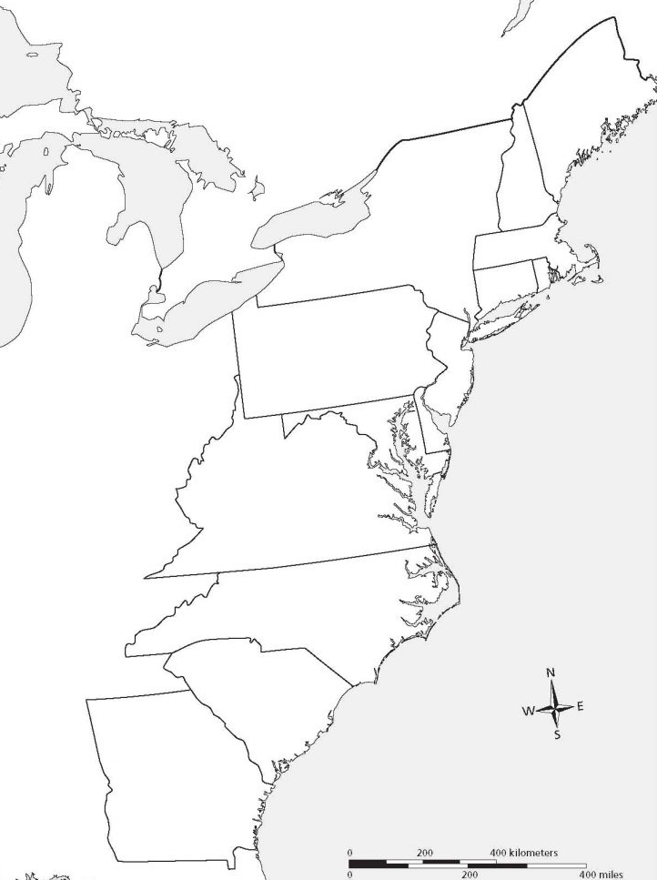
Economically, the colonies thrived on trade with the nations of Europe. Along with increasing population and prosperity, a new sense of identity was growing in the colonists’ minds. By the mid-1700s, colonists had been living in America for nearly 150 years. Each of the 13 colonies had its own government, and people were used to a great degree of independence. However, they were still British subjects and were expected to obey British law.
  - Colony Discontent Grows
    - _______________________________________
      - Passed in 1651
      - ________________________________________________________________
________________________________________________________________

      - ________________________________________________________________
________________________________________________________________

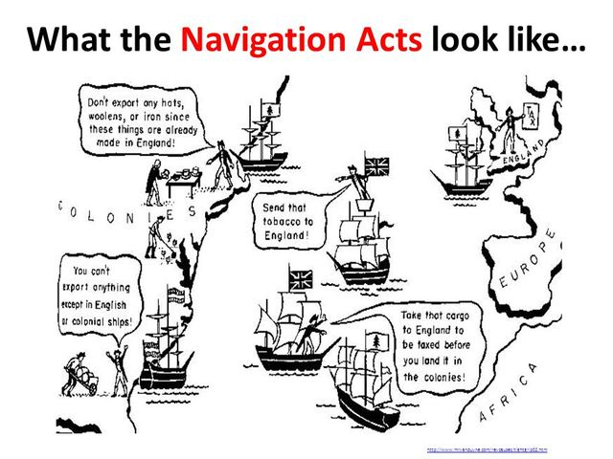
- ________________________________________________________________________________________________________________________________________________________________

- ________________________________________
________________________________________________________________________________

Nonetheless, Britain’s policies benefited both the colonies and the motherland. Britain bought American raw materials for low prices and sold manufactured goods to the colonists. And despite various British trade restrictions, colonial merchants also thrived. Such a spirit of relative harmony, however, soon would change.

- Reorganization, Resistance, and Rebellion
  - Immediate Causes of the Revolution

    - Great Britain’s Response to its victory over France in the Seven Year’s War (1756-1763)
      - Known as the French and Indian War in the American colonies
      - __________________________________________________________________
__________________________________________________________________
Because American colonists benefited from Britain’s victory, Britain expected the colonists to help pay the costs of the war. In 1765, Parliament passed the Stamp Act.

        - _______________________________________

          - Passed in 1765
          - Attempted to levy new taxes on the colonies

            - ________________________________________________
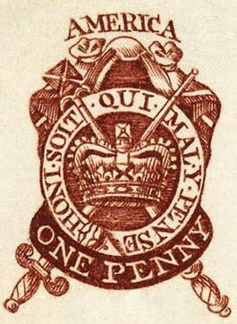

________________________________________________
________________________________________________
________________________________________________
            - Colonial lawyers argued that the stamp tax ____________ ________________________________________________ and they accused the government of “ ________________ _______________________________________________”
            - ________________________________________________
________________________________________________
              - Immediate crisis ended
              - Fundamental cause had not been resolved

  - Voting (__________________________)
    - Property requirements for voting
      - 1 in 5 men in Great Britain met requirements
      - 50% of colonist met requirements

    - Direct vs Indirect Representation

      - ___________________________________
        - ________________________________________
        - ___________________________________________________________
___________________________________________________________
      - ____________________________________
        - _______________________________________
        - ___________________________________________________________
___________________________________________________________
        - ___________________________________________________________

  - Role of the British Empire
    - ________________________________________________________________________
    - ______________________________________________________________ throughout the empire (including the colonies)
    - ___________________________ in the empire were ____________________________
___________________________ by members of Parliament
    - Real _______________________ to _______________________ resided in __________
      - Any colonial assemblies could only make temporary by-laws
    - American view of British Empire
      - By 1760 American colonists developed a sense of common identity
      - Great Britain represented “old” while American colonies represented “youthfulness”

Over the next decade, hostilities between the two sides increased. Some colonial leaders favored independence from Great Britain mainly as a result of resentment towards Great Britain.

  - Resentment leads to desire for independence
    - In 1773, to protest an import tax on tea, a group of colonists dumped a large load of British tea into Boston Harbor. George III, infuriated by the “Boston Tea Party,” as it was called, ordered the British navy to close the port of Boston.

    - ____________________________________
      - _________________________________
        - Seen as an attempt to ruin American colonial businesses
        - Protest erupted
          - 150 Americans dressed as Indians dumped tea into Boston Harbor
          - ____________________________________________________
____________________________________________________
    - __________________________________________

      - ___________________________________________________
      - ___________________________________________________
      - Strengthened the power of the royal governor of Massachusetts
      - Restrictions in place _________________________________________________
__________________________________________________________________
      - Restrictions backfire and _____________________________________________
__________________________________________________________________
    - _____________________________________________

      - Colonists met in Philadelphia in __________________________________
      - __________________________________________________________________
      - More radical members stressed the need to “take up arms and organize militias”
On April 19, 1775, British soldiers and American militia men exchanged gunfire on the village green in Lexington, Massachusetts. The fighting spread to nearby Concord.

    - Common Sense
      - __________________________________ by _____________________________ in January 1776
      - Within 3 months sold 120,000 copies
      - _________________________________________________________________
_________________________________________________________________
_________________________________________________________________
    - __________________________________________________
      - _________________________________________________________________
        - _________________________________________________________ of “life, liberty, and the pursuit of happiness”
        - Declared the colonies to be “free and independent states absolved from all allegiance to the British crown”
        - Authorized the _______________________________________________ under __________________________________
        - The American Revolution had begun!

    - War for Independence (________ - ________)

      - British Army vs Continental Army
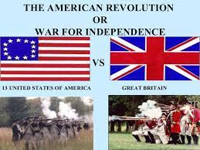

        - British – well trained
        - Continental – undisciplined amateurs

      - ____________________________________
        - October 1777
        - Why It’s Important!
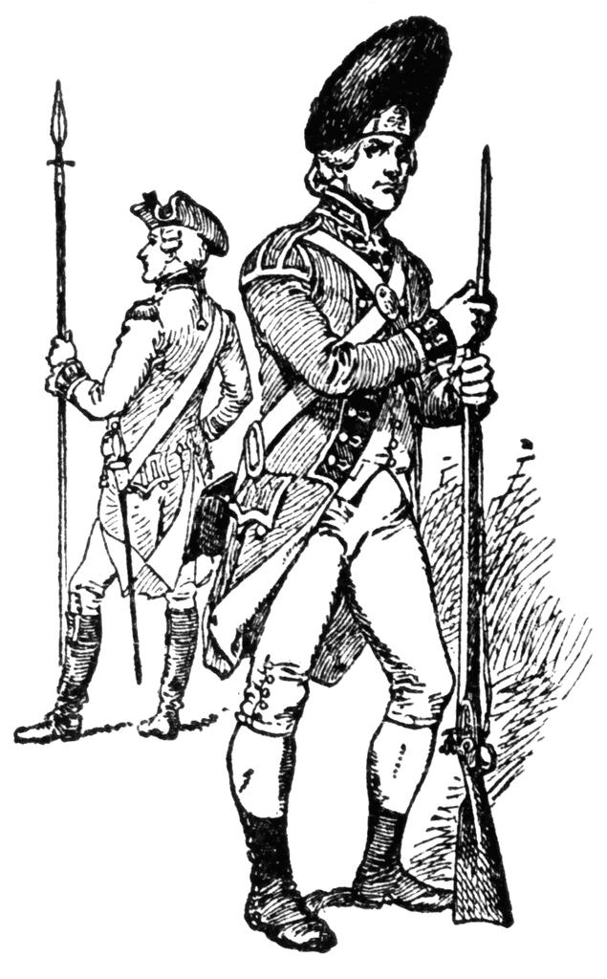

___________________________________________________________
___________________________________________________________
___________________________________________________________
      - Foreign Assistance to the Colonies

        - ___________________________________________________________
___________________________________________________________
        - Spain and Dutch Republic enter the war in 1779 and 1780
        - Russia formed the ____________________________________________ to protect neutral shipping from British attacks
        - British faced with war against much of Europe as well as the Colonists
          - Despite winning most of battles, the odds were stacking against the British
          - _____________________________________________________
_____________________________________________________
      - _______________________________________
        - Signed in _____________________
        - Why It’s Important!
- __________________________________________________________________________________________________________________
2. Granted Americans control of the western territory from the
Appalachians to the Mississippi River
  - Toward a New Nation

    - _____________________________________
      - 13 colonies feared concentrated power in strong central government. The Articles established the United States as a ____________________, a government in which citizens rule through elected representatives.
      - Articles of Confederation proposed in 1777, ratified in 1781- did very little to establish a strong central government. To protect their [state] authority, the 13 states created a loose confederation in which they held most of the power. Thus, the Articles of Confederation deliberately created a weak national government.
      - There were no executive or judicial branches. Instead, the Articles established only one body of government, ____________________. Each state, regardless of size, had one vote in Congress.
        - Congress could declare war, enter into treaties, and coin money. It had no power, however, to collect taxes or regulate trade. Passing new laws was difficult because laws needed the approval of 9 of the 13 states.
      - __________________________________________________________________ __________________________________________________________________
__________________________________________________________________ __________________________________________________________________

    - __________________________________________
      - Summer of 1787
      - ____________________________ attended convention in __________________
      - Delegates were familiar with the political theories of Locke, Montesquieu, and Rousseau
      - Meeting authorized for “the sole and express purpose of revising the Articles of Confederation”
      - Ultimately reject revision and decided to devise a new constitution
      - Although the delegates shared basic ideas on government, they sometimes dis-agreed on how to put them into practice. For almost four months the delegates
argued over important questions. Who should be represented in Congress? How
many representatives should each state have?
      - The delegates’ deliberations produced not only compromises but also new approaches to governing. Using the political ideas of the Enlightenment, the delegates created a new system of government.

    - __________________________________________
      - __________________________________________________________________
__________________________________________________________________
        - National government
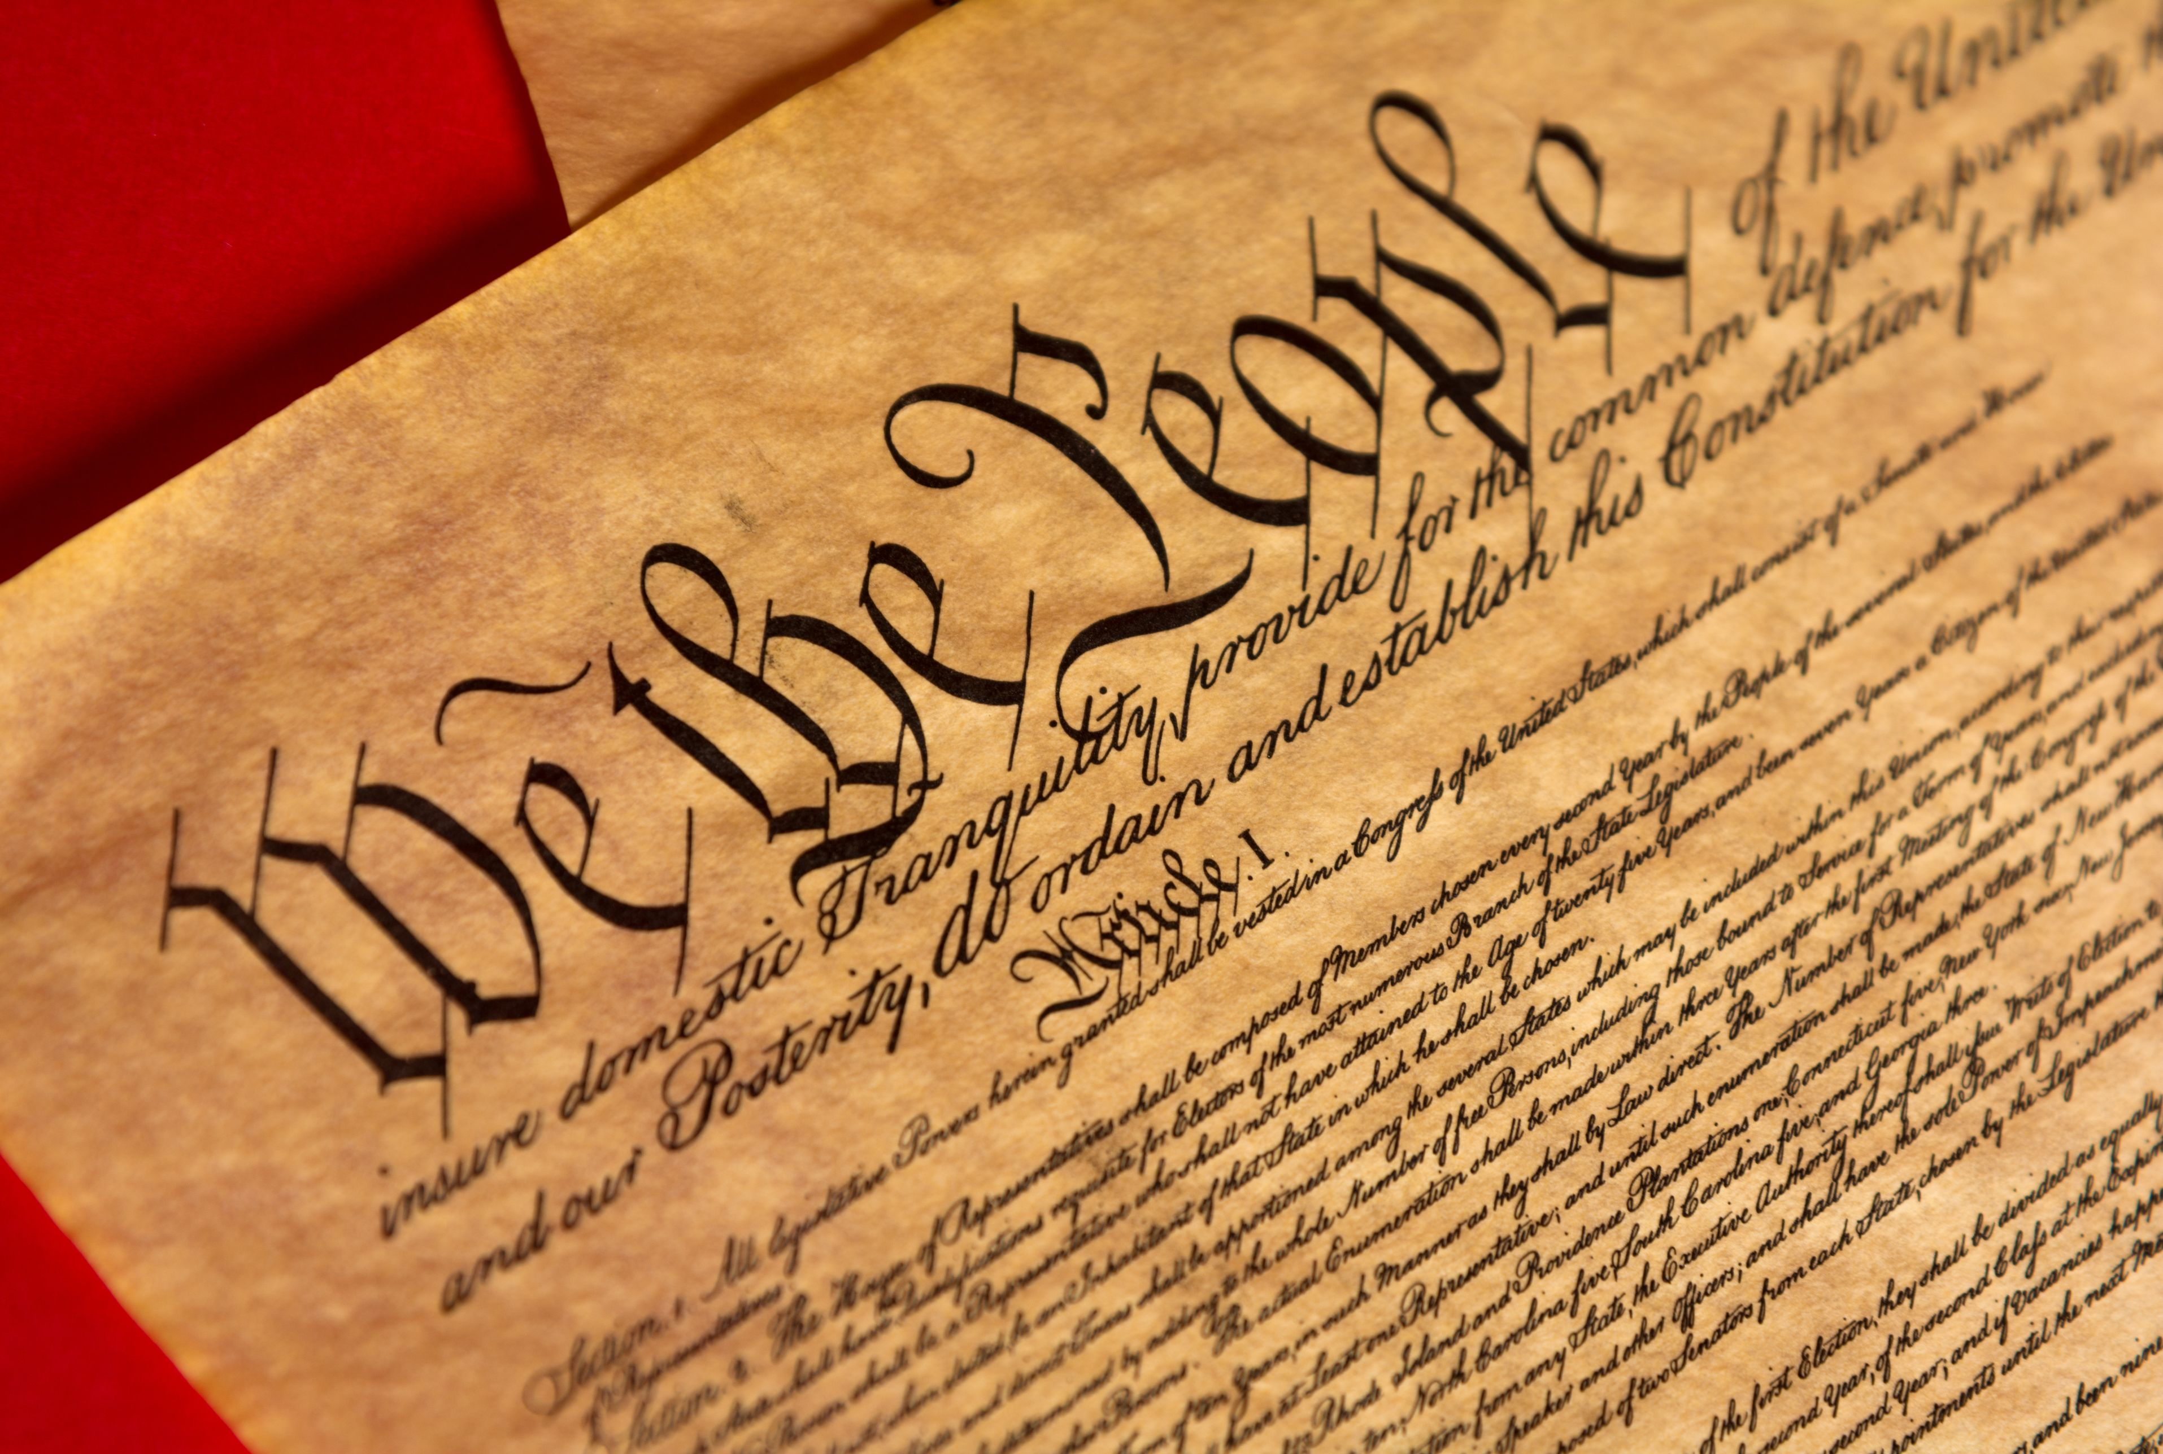

          - Levy taxes
          - Raise a national army
          - Regulate trade
          - Establish national currency
        - State governments
          - Not eliminated, but powers were diminished
          - the Constitution set up a federal system in which power was divided between national and state governments.
      - Established federal government
        - Like Montesquieu, the delegates distrusted a powerful central government controlled by one person or group.

        - Checks and Balances
          - President
          - Legislative
          - Judicial

      - Recognized as the “____________________________________________”
      - The delegates signed the new Constitution on September 17, 1787. In order to become law, however, the Constitution required approval by conventions in at least 9 of the 13 states.

      - The Federalists and the Antifederalists
        - Supporters of the Constitution were called _____________________. They argued in their famous work, _____________________________, that the new government would provide a better balance between national and state powers.
        - Their opponents, the _________________________________, feared that the Constitution gave the central government too much power. They also wanted a __________________________________ to protect the rights of individual citizens.
      - In order to gain support, the Federalists promised to add a bill of rights to the
Constitution. This promise cleared the way for approval. Congress formally added to the Constitution the ___________________________________ known as the Bill of Rights. These amendments protected such basic rights as freedom of speech, press, assembly, and religion. Many of these rights had been advocated by Voltaire, Rousseau, and Locke.
      - The Constitution and Bill of Rights marked a turning point in people’s ideas about government. Both documents _________________________________________
__________________________________________________________________.

- _________________________________________________
  - ______________________________________________________________________________
______________________________________________________________________________
    - When colonists were refused the same political rights as people in Great Britain, colonist argued that the “___________________________” had been broken
  - Declaration of Independence written by political leader Thomas Jefferson
    - Jefferson _____________________________________________________________
      - _______________________________________
        - “We hold these truths to be self-evident,” states the beginning of the Declaration, “that all men are created equal, that they are endowed by their Creator with certain unalienable rights, that among these are life, liberty, and the pursuit of happiness.”

        - Since Locke had asserted that people had the right to rebel against an unjust ruler, the Declaration of Independence included a long list of George III’s abuses. The document ended by declaring the colonies’ separation from Britain. The colonies, the Declaration said, “are absolved from all allegiance to the British crown.”

Enlightenment Thinker | Enlightenment Idea | US Constitution
- Preamble begins with “We the people of the United States” to establish legitimacy.
- Creates representative government
- Limits government powers

- Federal system of government
- Powers divided among three branches
- System of checks and balances
- Public election of president
- Public election of Congress

 |  | - Bill of Rights provides for freedom of speech and freedom of religion

The Constitution and Bill of Rights marked a turning point in people’s ideas about government. Both documents put Enlightenment ideas into practice. They expressed an optimistic view that reason and reform could prevail and that progress was inevitable. Such optimism swept across the Atlantic. However, the
monarchies and the privileged classes didn’t give up power and position easily. Our next packet explains how the struggle to attain the principles of the Enlightenment led to violent revolution in France.

Review:
- Discuss some things that Great Britain did to push the colonists towards a war for independence.

What could Great Britain have done to avoid a war?

- Why did the Stamp Act upset the colonist?

- What were some reasons for American success in the War for Independence despite the odds being overwhelmingly against them?

- Why did the colonist create a weak central government at first?

- How did the Enlightenment influence the American colonies?

Do you think there would have been a revolution if there had not been an Enlightenment?

- Summarize the ideas from the American Revolution concerning separation of powers, basic rights of freedom, and popular sovereignty.

